TESTING OF THE WEB UI

STEP 1 – By clicking on the below given link install the application

[https://drive.google.com/file/d/1OOFvB0djAvVO2Q3poYnwjCjL3SAB_69L/view?u sp=drivesdk](https://drive.google.com/file/d/1OOFvB0djAvVO2Q3poYnwjCjL3SAB_69L/view?usp=drivesdk)

STEP 2 - Open the application ,then it will be redirected to the home page .Enter the login credentials i.e., user name and password .Click on submit .

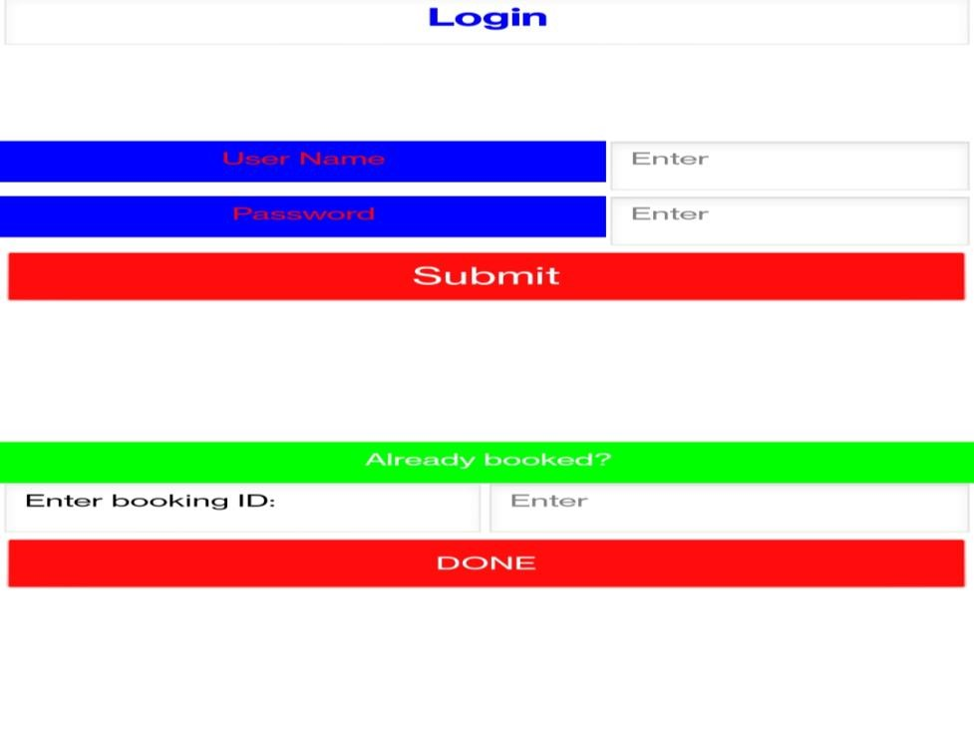

STEP 3 – Click on book a ticket now option.



STEP 4 - By clicking on the icon ,further details like the passengers Name ,Phone number, Train name ,from and to as well as the journey date the user can book their ticket by clicking on confirm followed by done option .

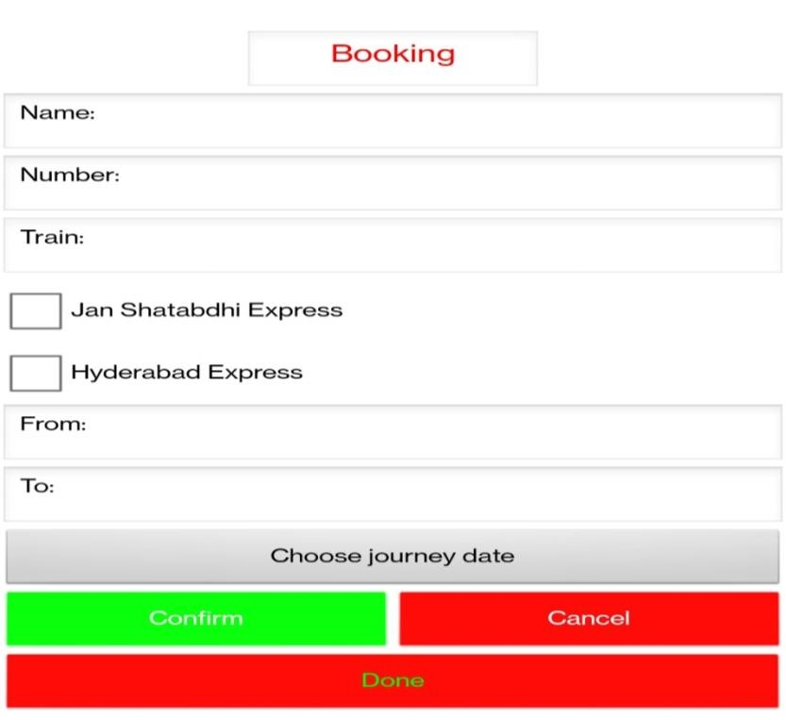

STEP 5 - Note your booking id’ . If any crisis arise click on the “REPORT

TRAVELLING ISSUES HERE”



STEP 6 – In the listed options click the appropriate query of your’s .

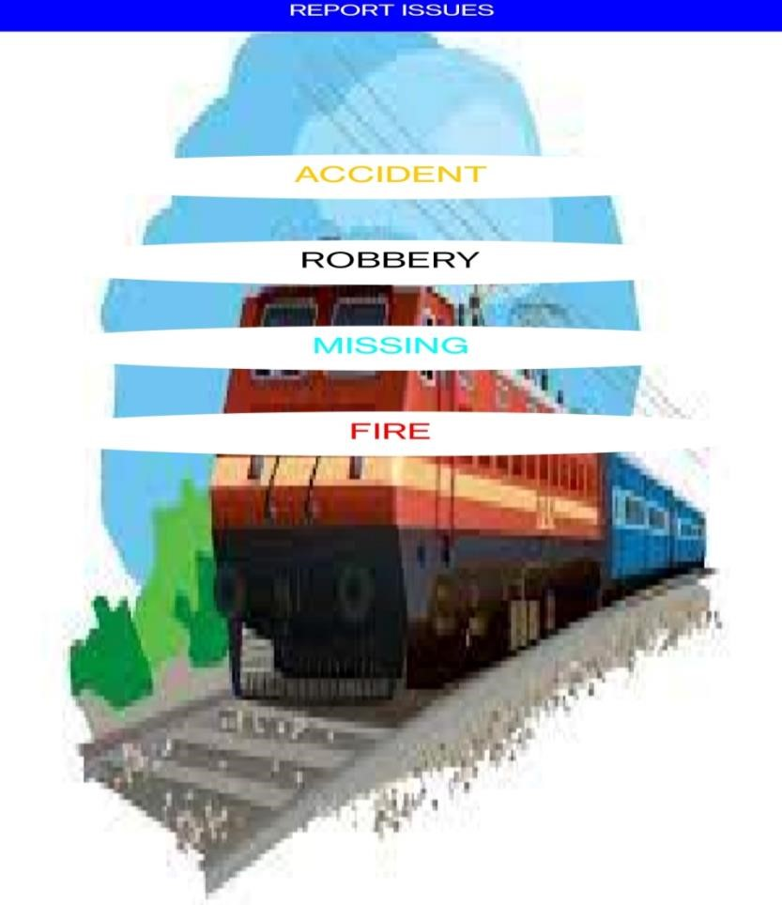

STEP 7 - Thus the issue of yours will be reported. And an alert will be sent to the respected officials.

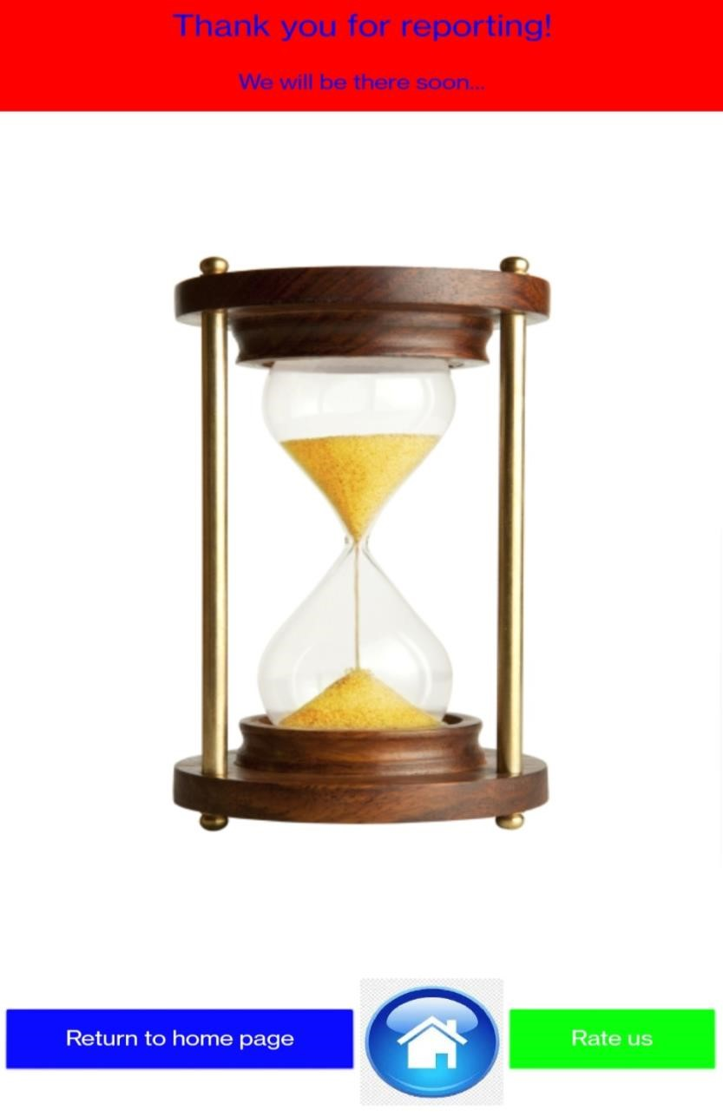

STEP 8 - Hence by clicking on the return to home page option you’ll be redirected to your home page .